SIMATS ENGINEERING

ASSESSMENT TOOL 1

COURSE NAME: Database Management Systems COURSE CODE: CSA05

COURSE OUTCOME COVERED

CO2: Apply the relational model, relational algebra, SQL query structures, and views to solve database querying and data manipulation problems. (BL3, BL6)

Activity Tool: Analytical Problem Solving (High) Assessment Tool Weightage: 40%

QUESTIONS
Q.N  o | Question | Bloom's Level
1 | Given a set of relations and sample data, write SQL queries to retrieve specific information using joins and subqueries, and explain the logic used.  Bloom’s Level: BL3 – Apply | BL4 – Analyze
2 | Using relational algebra, formulate expressions to solve complex queries such as retrieving records that satisfy multiple conditions across relations.  Bloom’s Level: BL4 – Analyse | BL5 – Evaluate
3 | Given a real-world scenario (e.g., banking or student system), design a relational schema and construct appropriate SQL queries for data retrieval and updates. Bloom’s Level: BL6 – Create | BL6 – Create
4 | Analyse a given SQL query with nested subqueries and predict its output, explaining each step of execution.  Bloom’s Level: BL4 – Analyze | BL6 – Create
5 | Compare different SQL approaches (joins vs subqueries) for solving the same problem and evaluate their efficiency. Bloom’s Level: BL5 – Evaluate | BL4 – Analyze
6 | Design and implement views for a database system to provide restricted data access, and justify their use for security and abstraction.  Bloom’s Level: BL6 – Create | BL5 – Evaluate
7 | Given a database schema, write relational algebra expressions and convert them into equivalent SQL queries, analyzing differences in representation.  Bloom’s Level: BL4 – Analyze | BL4 – Analyze

8 | Optimize a set of inefficient SQL queries by restructuring them using joins, indexing concepts, or views, and evaluate performance improvements.  Bloom’s Level: BL5 – Evaluate | BL5 – Evaluate
9 | Develop a complex SQL query involving grouping, aggregation, and nested queries to solve a real-world problem.  Bloom’s Level: BL6 – Create | BL6 – Create
10 | Given multiple relations, analyze the query requirements and decide whether to use views, joins, or subqueries, justifying your choice with reasoning.  Bloom’s Level: BL5 – Evaluate | BL5 – Evaluate

Code of Conduct:

I Nisha.R(192311415) (Name / Reg No) certify that this submission is my original work and that I have adhered to the guidelines specified for this assessment. I understand that any violation of academic integrity rules will result in disciplinary action.
Signature of the student:
Nisha

Q1. Given a set of relations and sample data, write SQL queries to retrieve specific information using joins and subqueries, and explain the logic used.
Output:

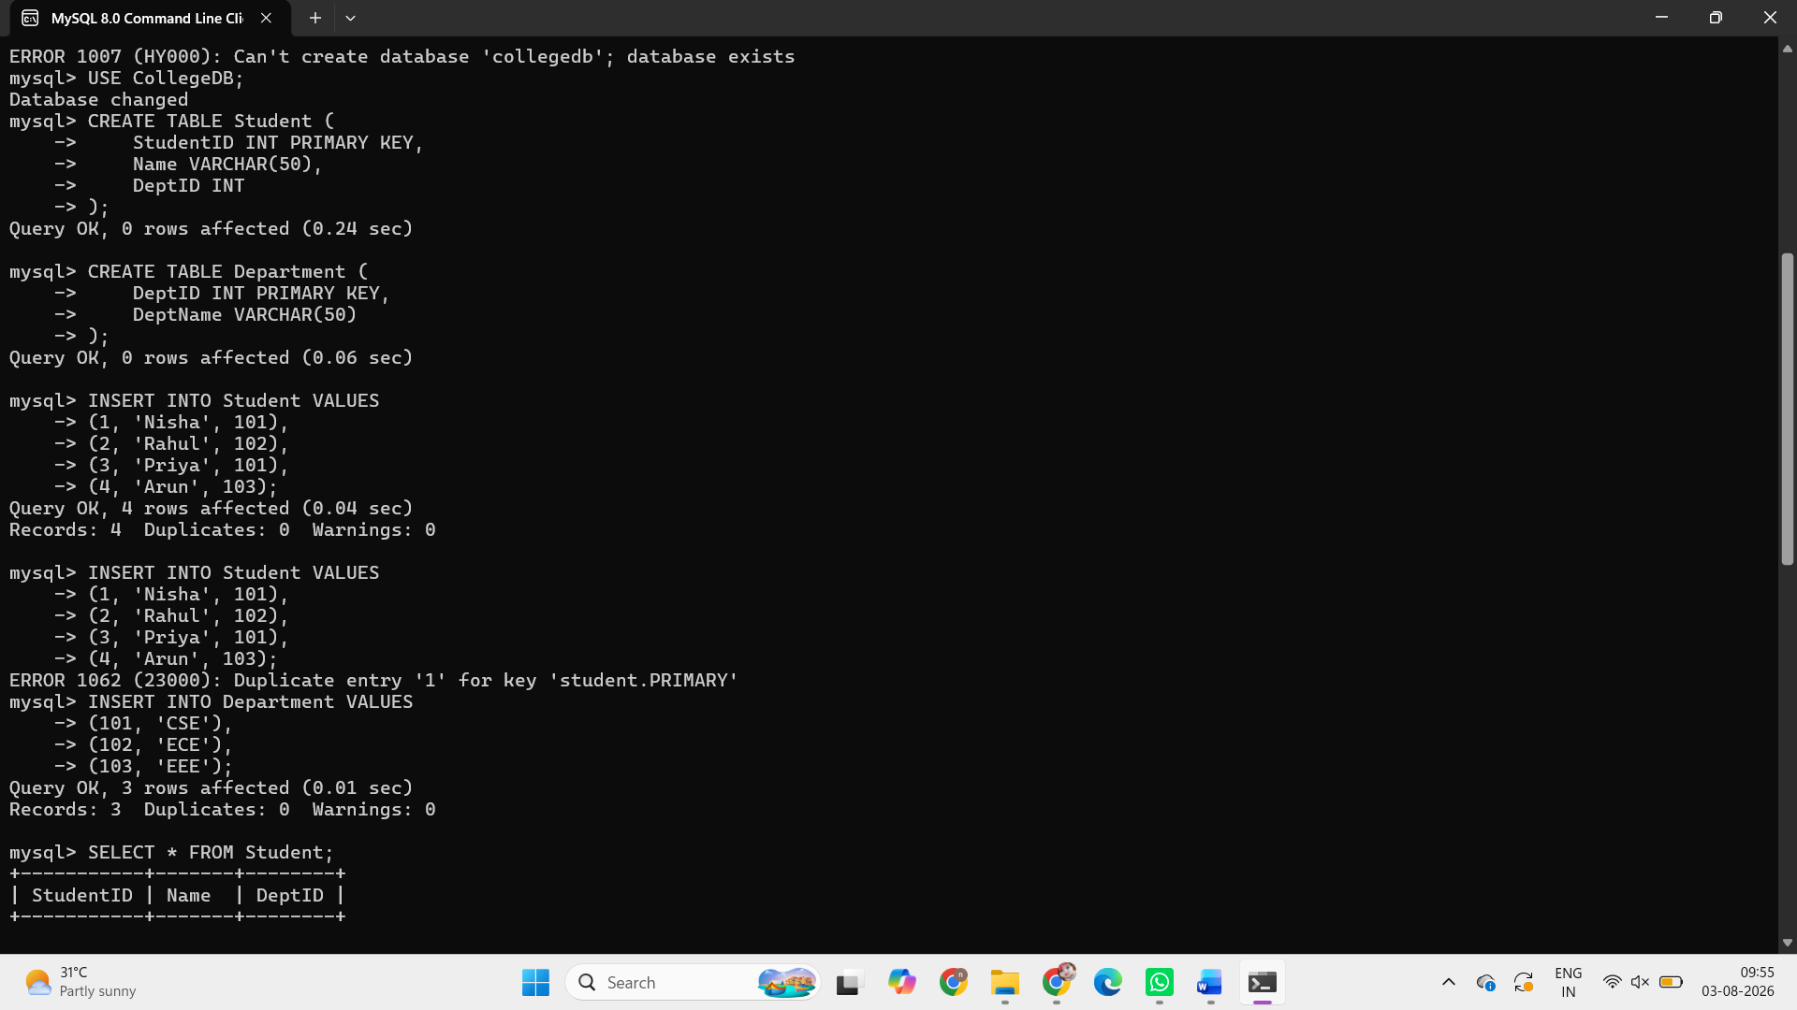
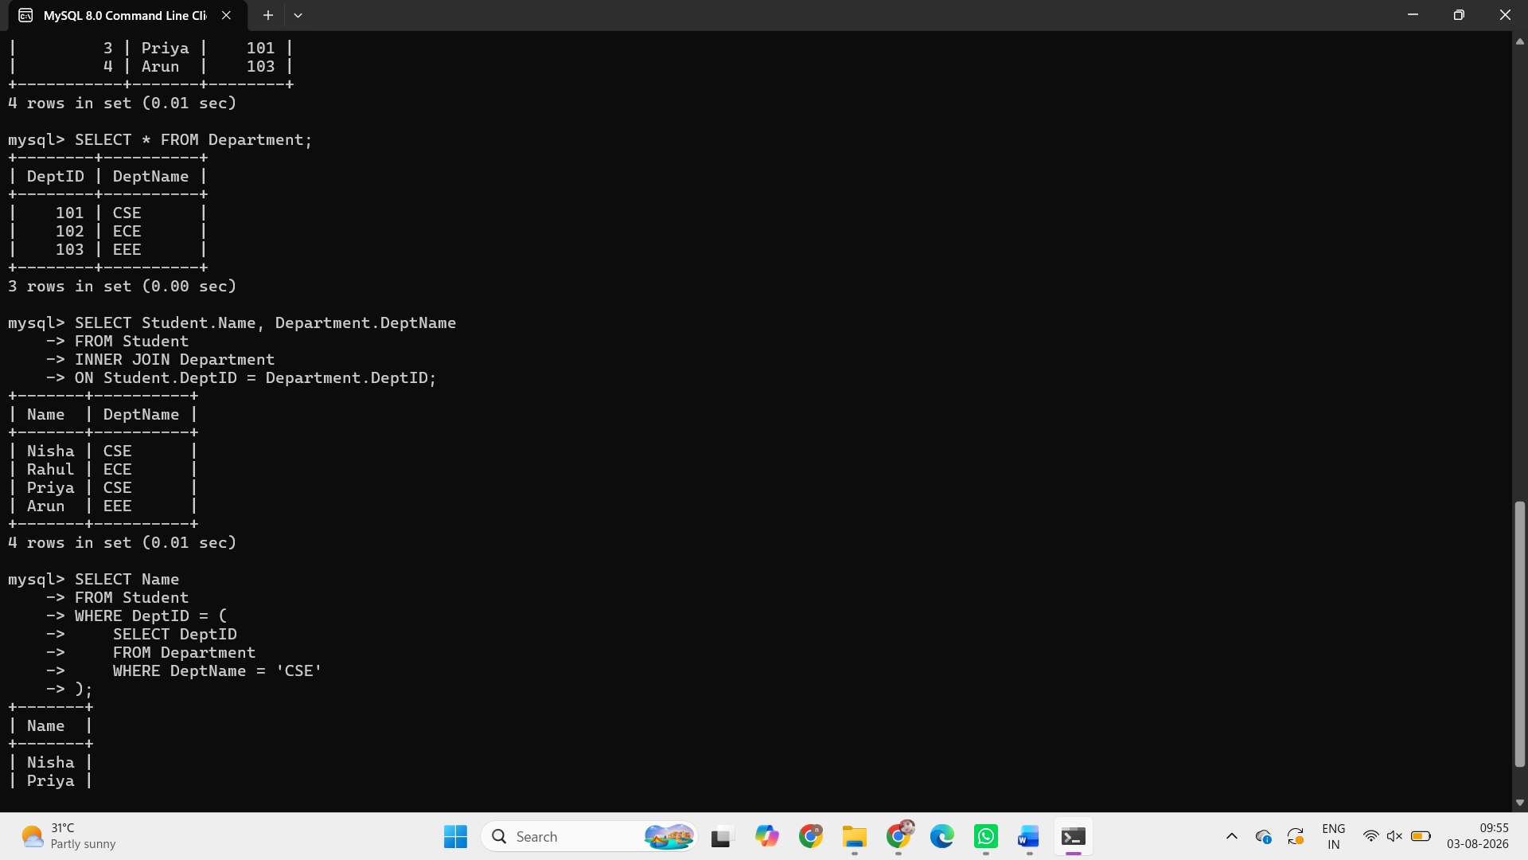

Q2. Using relational algebra, formulate expressions to solve complex queries such as retrieving records that satisfy multiple conditions across relations.
Answer:
Students in the CSE Department
$$π_{Name}\left(σ_{DeptName=^{'}CSE^{'}}\left(Student⋈_{Student.DeptID=Department.DeptID}Department\right)\right)$$

2. Students in the CSE or ECE Departments
$$π_{Name}\left(σ_{DeptName=^{'}CSE^{'} ∨ DeptName=^{'}ECE^{'}}\left(Student⋈_{Student.DeptID=Department.DeptID}Department\right)\right)$$

3. Students in the CSE Department with StudentID > 1
$$π_{Name}\left(σ_{DeptName=^{'}CSE^{'} ∧ StudentID>1}\left(Student⋈_{Student.DeptID=Department.DeptID}Department\right)\right)$$

4. Students in the EEE Department
$$π_{Name}\left(σ_{DeptName=^{'}EEE^{'}}\left(Student⋈_{Student.DeptID=Department.DeptID}Department\right)\right)$$

Q3. Given a real-world scenario (e.g., banking or student system), design a relational schema and construct appropriate SQL queries for data retrieval and updates.
Output:
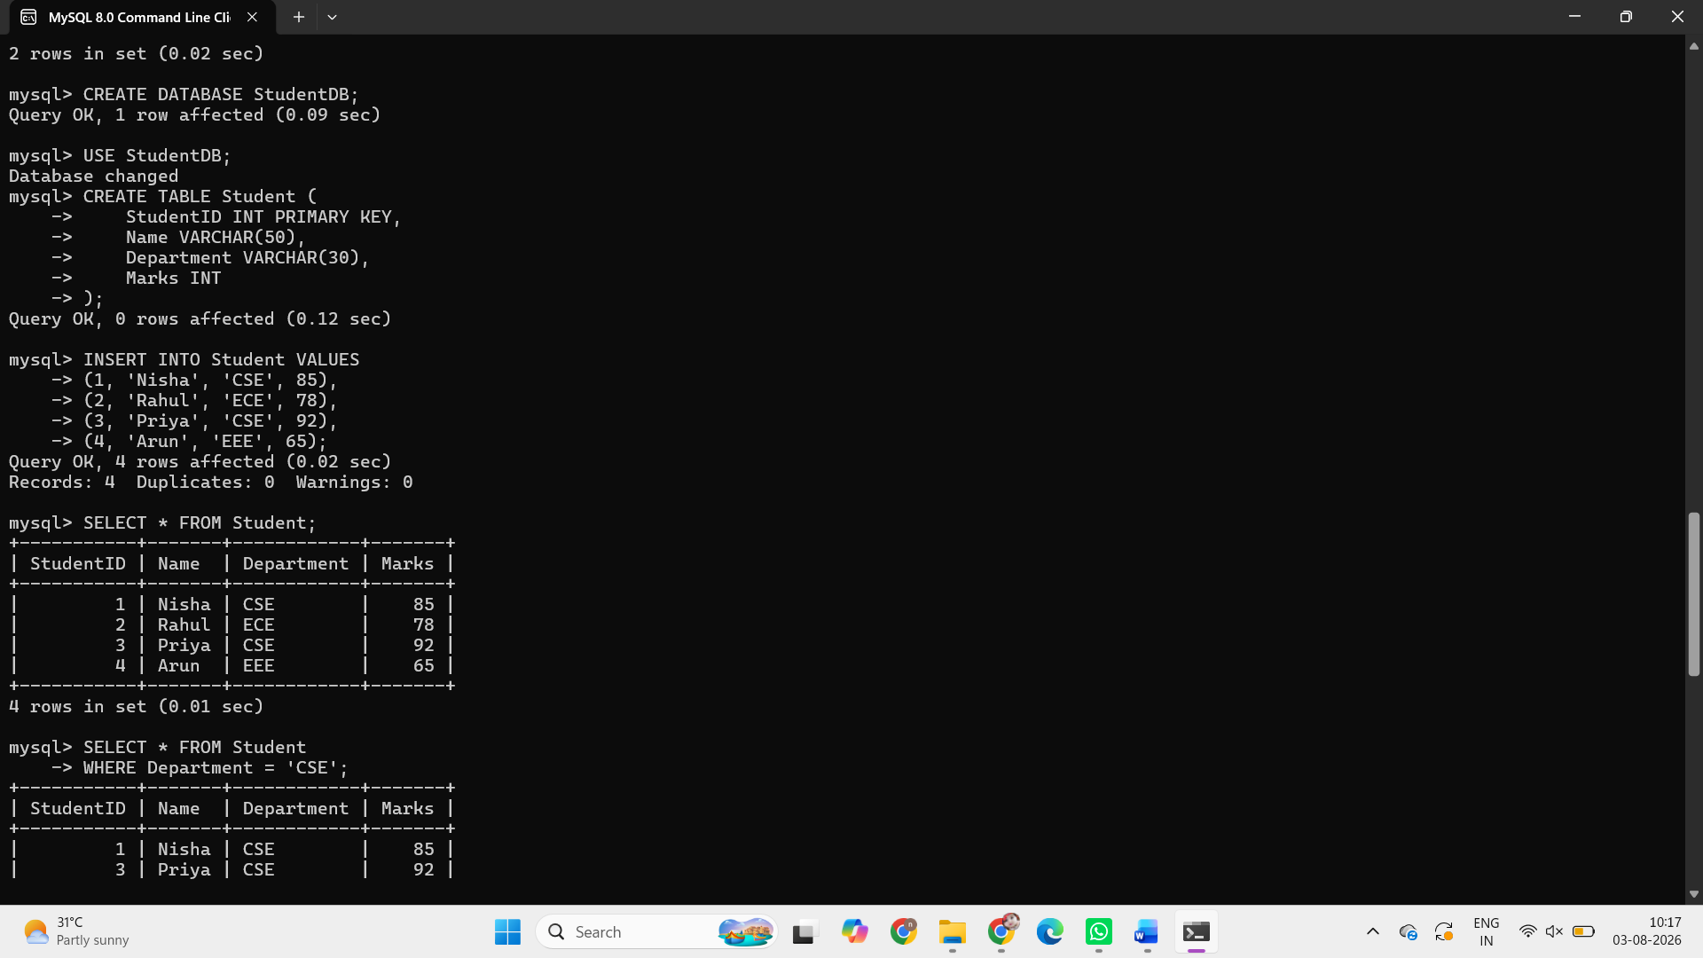
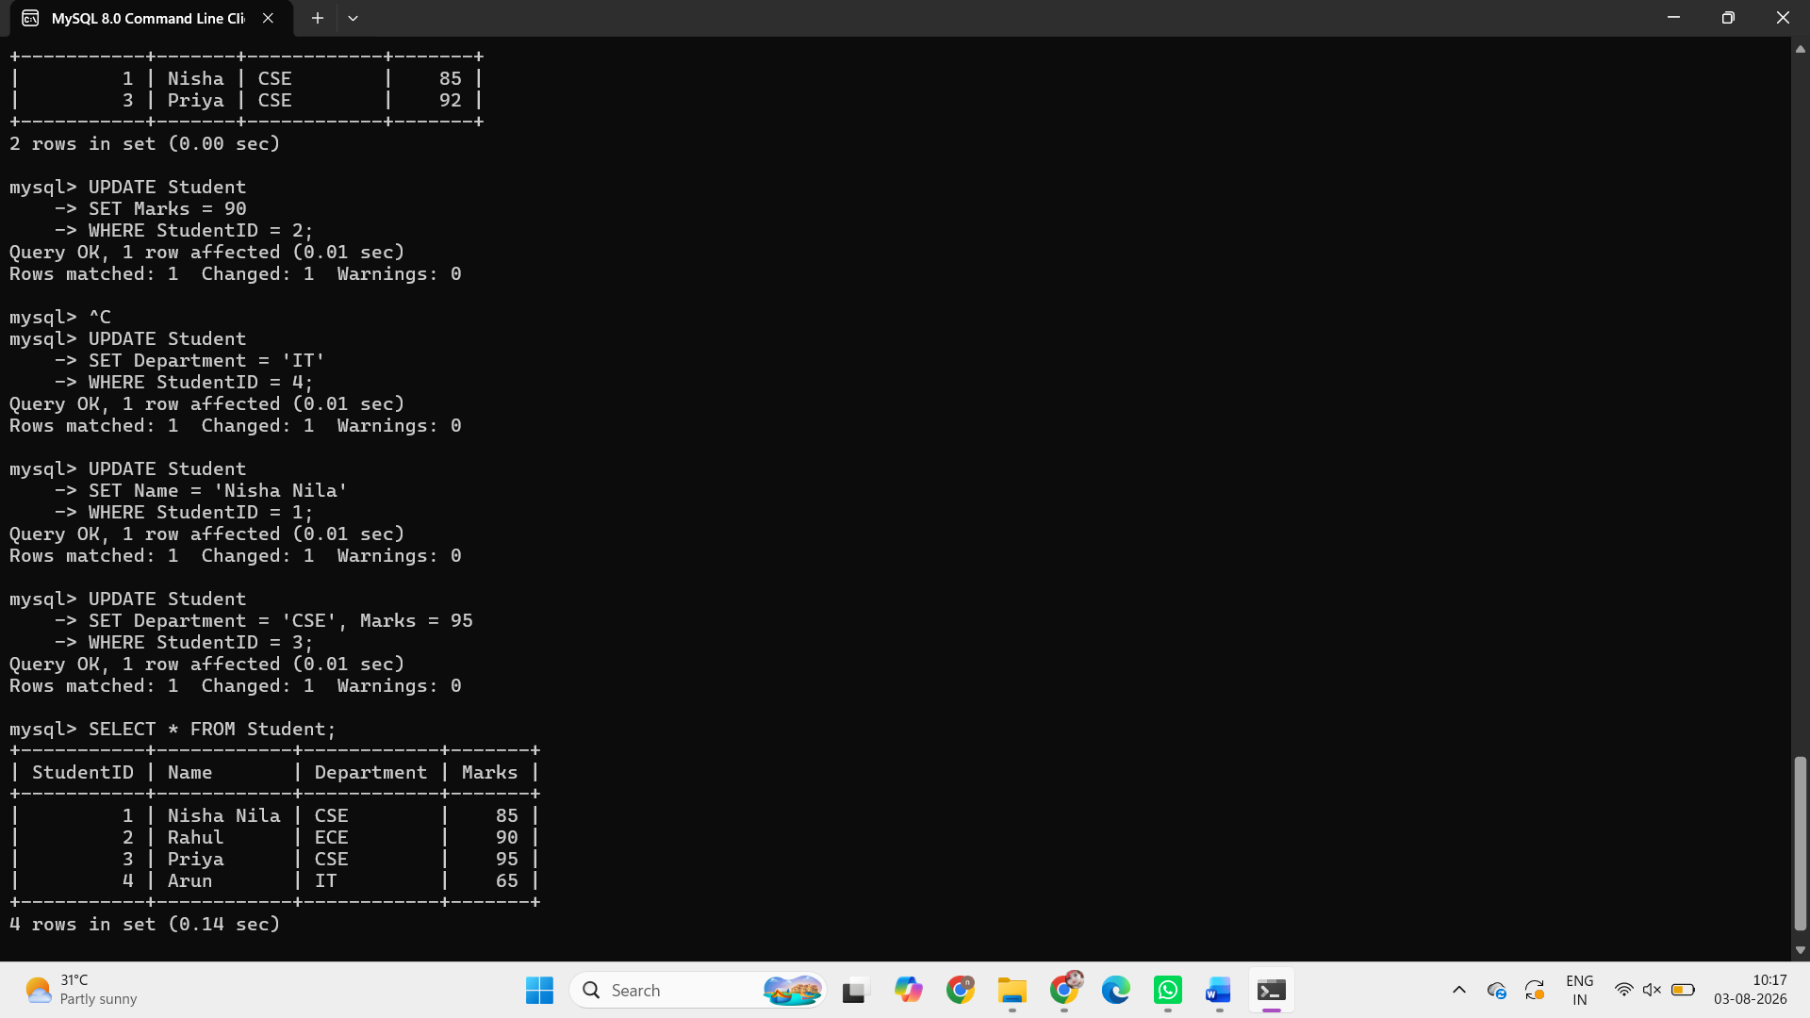

Q4. Analyse a given SQL query with nested subqueries and predict its output, explaining each step of execution.
Output:
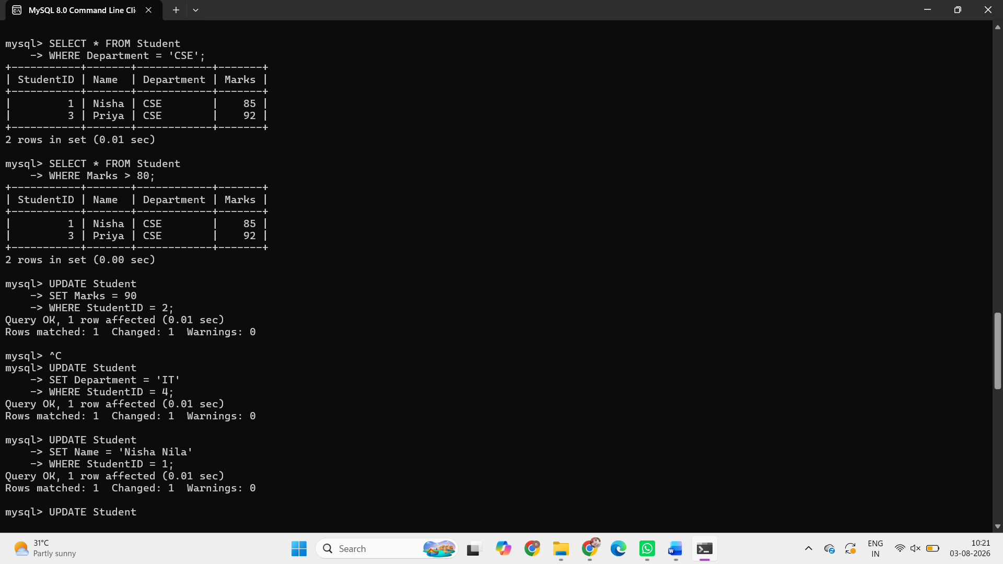
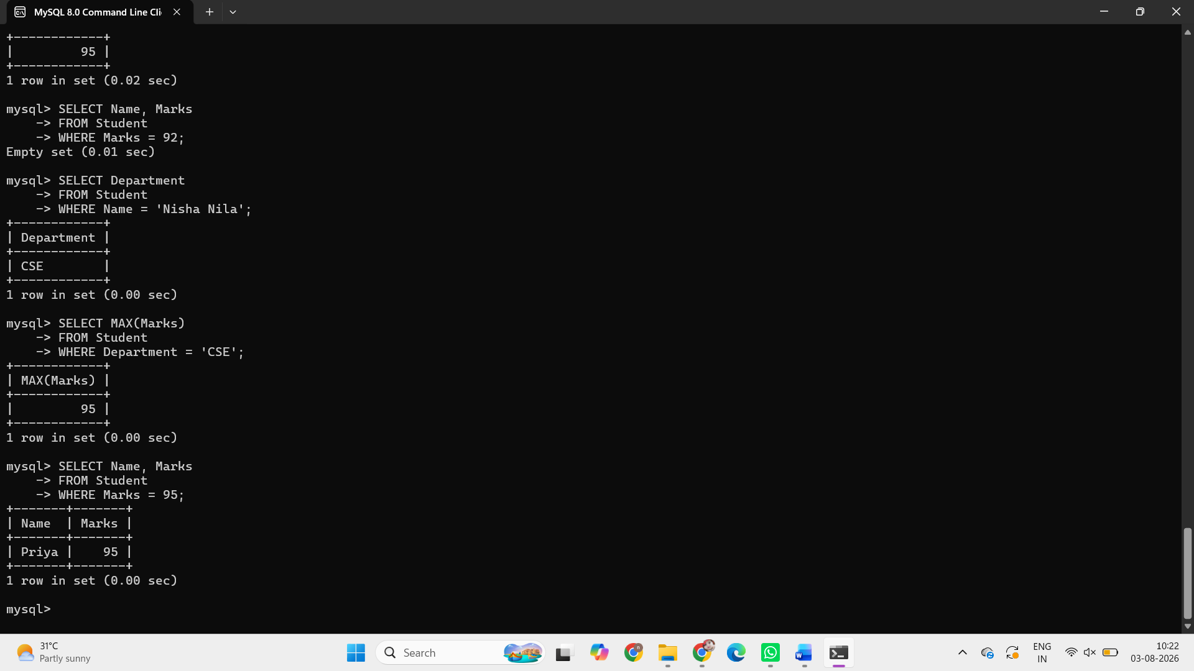

Q5. Compare different SQL approaches (joins vs subqueries) for solving the same problem and evaluate their efficiency

Query 1: JOIN Approach

mysql> SELECT
-> s.StudentName,
-> s.Course,
-> s.Grade,
-> en.Subject,
-> en.Credits,
-> en.Semester
-> FROM Students s
-> JOIN Enrollments en ON s.StudentID = en.StudentID
-> ORDER BY s.StudentName;
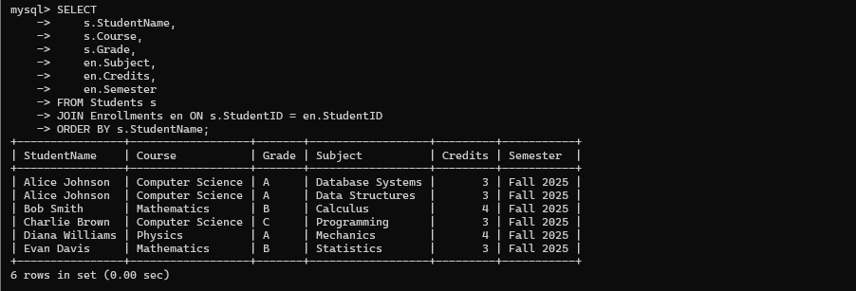

Output: This approach shows ALL students with their enrollments

StudentName | Course | Grade | Subject | Credits | Semester
Alice Johnson | Computer  Science | A | Database  Systems | 3 | Fall 2025
Alice Johnson | Computer  Science | A | Data  Structures | 3 | Fall 2025
Bob Smith | Mathematics | B | Calculus | 4 | Fall 2025
Charlie Brown | Computer  Science | C | Programming | 3 | Fall 2025
Diana  Williams | Physics | A | Mechanics | 4 | Fall 2025
Evan Davis | Mathematics | B | Statistics | 3 | Fall 2025

Query 2: Subquery Approach
mysql> SELECT
-> StudentID,
-> StudentName,
-> Course,
-> Grade
-> FROM Students
-> WHERE StudentID IN (
-> SELECT StudentID
-> FROM Enrollments
-> GROUP BY StudentID
-> HAVING COUNT(*) > 1
-> );
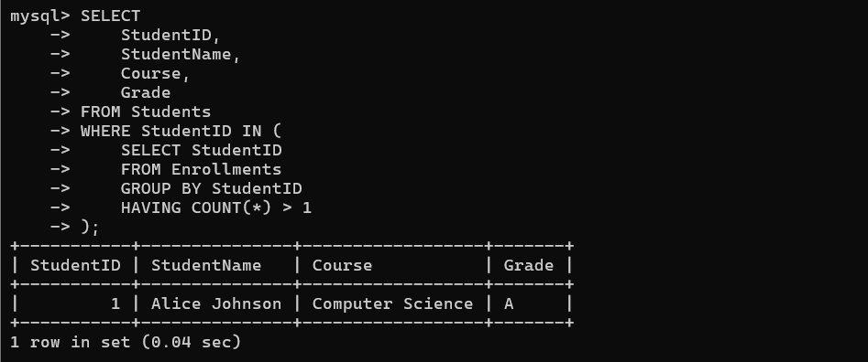

Output:

StudentID | StudentName | Course | Grade
1 | Alice Johnson | Computer Science | A

Q6. Design and implement views for a database system to provide restricted data access, and justify their use for security and abstraction.

View 1: Student Basic Information (Security) Problem:

Teachers should see student names and courses but NOT grade

Query:
mysql> CREATE VIEW StudentBasicInfo AS
-> SELECT
-> StudentID,
-> StudentName,
-> Course
-> FROM Students;
mysql> SELECT * FROM StudentBasicInfo;

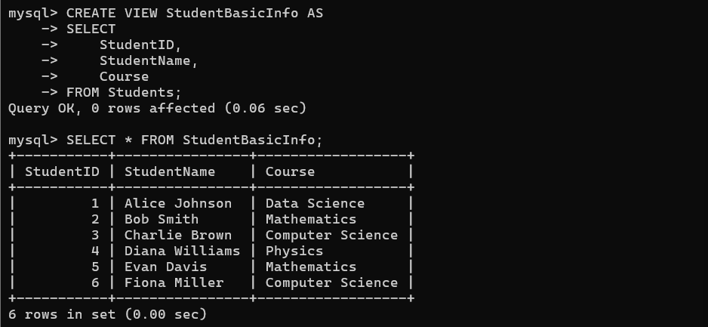

Output:

StudentId | StudentName | Course
1 | Alice Johnson | Data Science
2 | Bob Smith | Mathematics
3 | Charlie Brown | Computer Science
4 | Diana Williams | Physics
5 | Evan Davis | Mathematics
6 | Fiona Miller | Computer Science

View 2: Enrollment Details (Abstraction) Problem:
Administrators need to see student enrollment details without writing complex JOIN queries.

Query:

mysql> CREATE VIEW EnrollmentDetails AS
-> SELECT
-> s.StudentName,
-> s.Course,
-> en.Subject,
-> en.Credits,
-> en.Semester
-> FROM Students s
-> JOIN Enrollments en ON s.StudentID = en.StudentID; mysql> SELECT * FROM EnrollmentDetails;
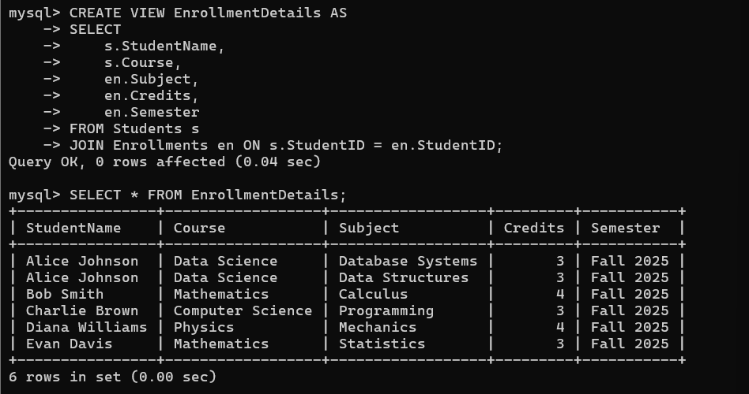

Output:

StudentName | Course | Subject | Credits | Semester
Alice Johnson | Data Science | Database  Systems | 3 | Fall 2025
Alice Johnson | Data Science | Data Structures | 3 | Fall 2025
Bob Smith | Mathematics | Calculus | 4 | Fall 2025
Charlie Brown | Computer  Science | Programming | 3 | Fall 2025
Diana Williams | Physics | Mechanics | 4 | Fall 2025
Evan Davis | Mathematics | Statistics | 3 | Fall 2025

Q7. Given a database schema, write relational algebra expressions and convert them into equivalent SQL queries, analyzing differences in representation.

Notation:
π StudentName (
σ Course='Computer Science' (Students)
𝔚
σ Subject='Database Systems' (Enrollments)
)

Query:
mysql> SELECT DISTINCT s.StudentName
-> FROM Students s
-> INNER JOIN Enrollments e ON s.StudentID = e.StudentID
-> WHERE s.Course = 'Data Science'

-> AND e.Subject = 'Database Systems';
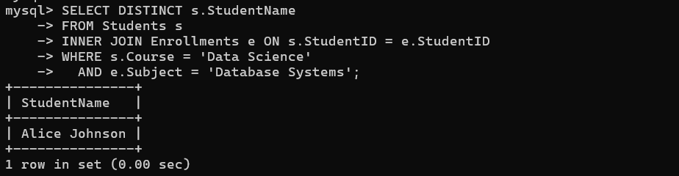

Output:

StudentName
Alice Johnson

Q8. Optimize a set of inefficient SQL queries by restructuring them using joins, indexing concepts, or views, and evaluate performance improvements. Bloom’s Level: BL5 – Evaluate Inefficient Query:
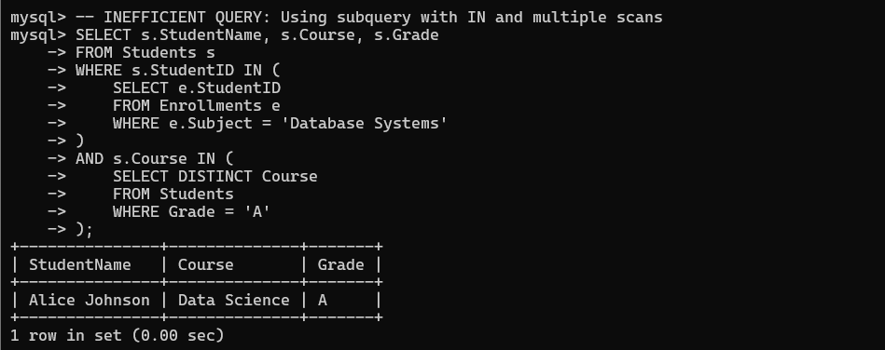

Performance Issues:
  - Multiple subquery executions
  - No proper indexing
  - Scans entire Students table multiple times
  - IN clause with subquery causes nested loop operations

Using Join:
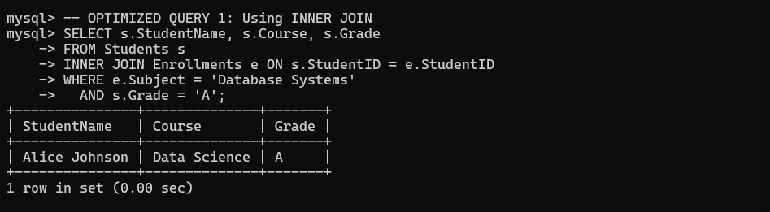

Using View:
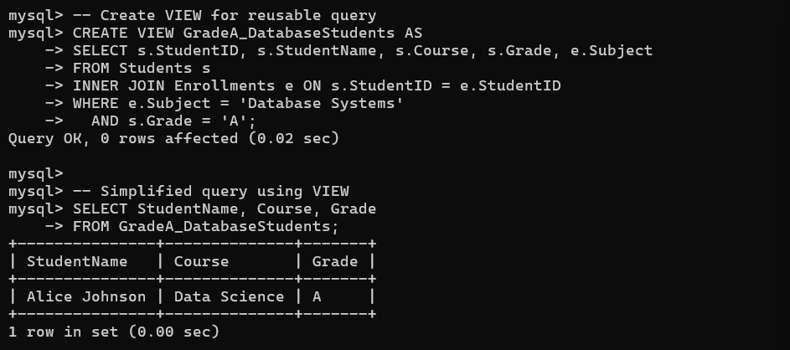

Using Index:
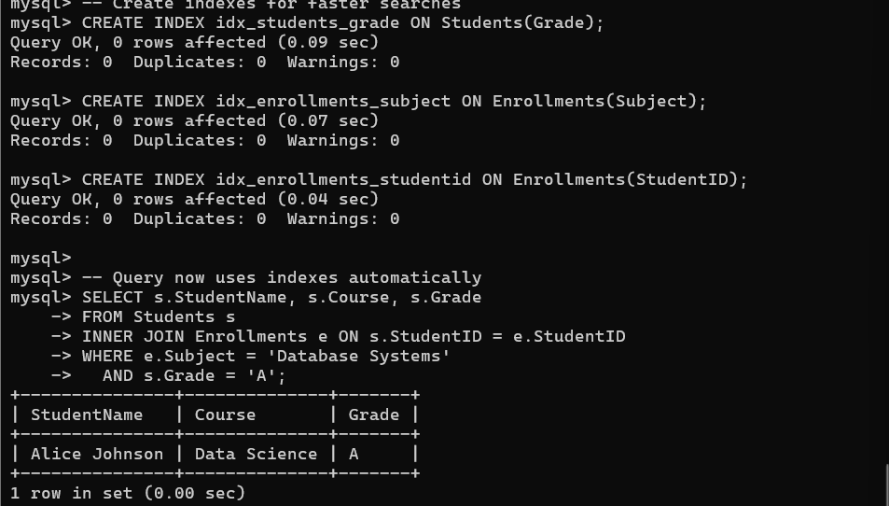

Q9. Develop a complex SQL query involving grouping, aggregation, and nested queries to solve a real-world problem. Bloom’s Level: BL6 – Create

Problem:
Find students who have taken at least 2 courses and have an 'A' grade, showing their total courses and ranking them by performance

Query & Output:
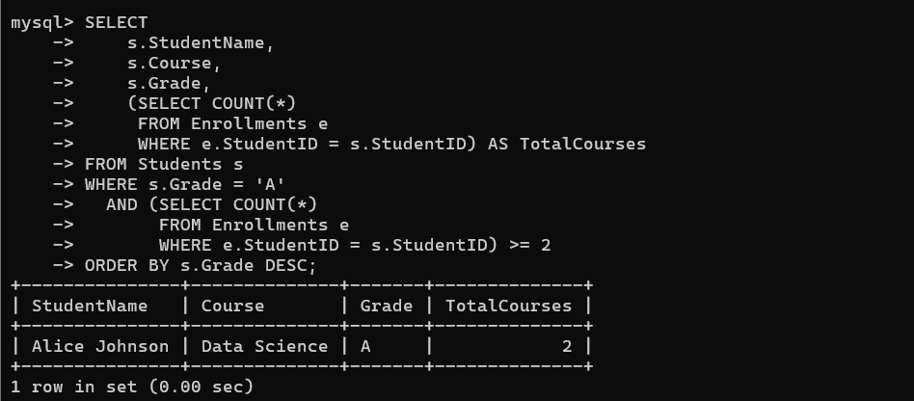

Q10.Given multiple relations, analyze the query requirements and decide whether to use views, joins, or subqueries, justifying your choice with reasoning. Bloom’s Level: BL5 – Evaluate

Scenario:
Management needs daily reports of student performance showing student names, their course, grade, and total number of courses enrolled.

Using JOIN
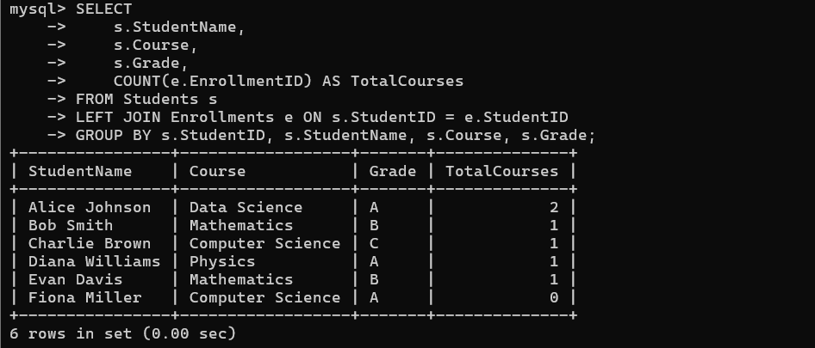

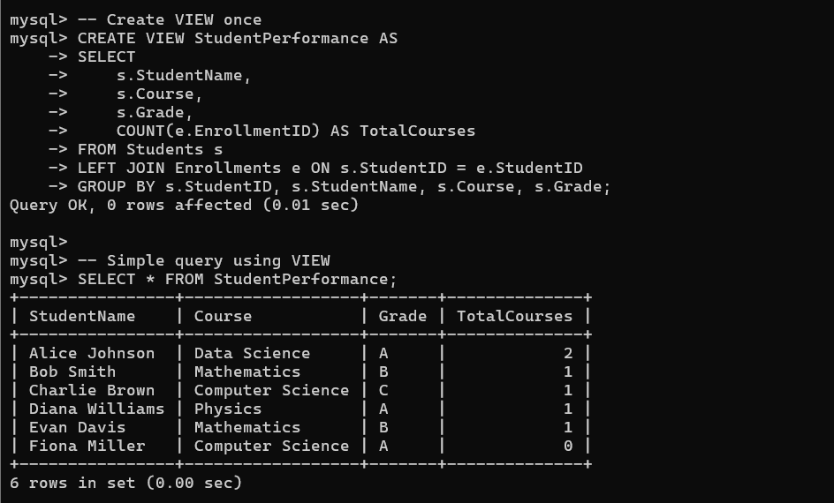

Using Subquery:
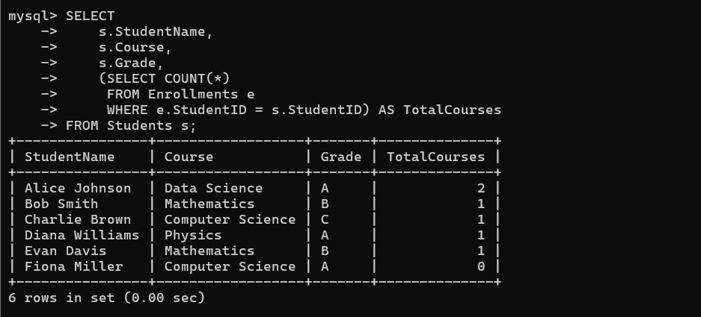

RUBRICS FOR CALCULATION:

Criteria | Level 4 (Exemplary) | Level 3 (Proficient) | Level 2 (Developing) | Level 1 (Beginning  )
Problem Understandin g | Clearly interprets problem, identifies all parameters and requirements accurately | Understand s problem with minor gaps | Partial understandin g; misses key elements | Misinterpret s or unable to understand problem
Method Selection | Selects most appropriate method/formul a with strong justification | Selects correct method with minor errors | Inappropriate or partially correct method | Unable to select method
Solution Process | Logical, systematic steps with correct approach throughout | Mostly correct steps with minor mistakes | Disorganized steps; multiple errors | No clear process
Accuracy of Calculation | All calculations accurate; | Minor calculation errors | Frequent errors; incorrect final answer | No valid calculations

correct final
answer
Interpretation of Results | Clearly interprets results with units and engineering relevance | Basic interpretatio n with minor omissions | Limited or unclear interpretation | No interpretatio n

